***Name:***

***Dawood Sarfraz***

***Roll no:***

***20p-0153***

***Section:***

***BSCS-5B***

***Home work:***

***03***

***File Sharing Between Two Computers using LAN***

***FAST-NUCES Peshawar Campus***

***Step1: Connect Both PC’s With LAN Cable***

**Connect both computers to a LAN cable.**

**Step 2: Enable Network Sharing on Both PCs**

**1- Goto Control Panel->Network and Internet->Network and Sharing Center->Advanced**

**sharing settings.**

**2- Next, expand All Networks by clicking on the drop-down icon. Here, we need to**

**enable Public Sharing so that the PCs can access files from each other over the LAN**

**cable. To avoid more configuration, just Turn off password protected sharing. By doing**

**so, you enable the other computer to access shared data without providing any**

**credentials. This is not a good security practice by since you are sharing your data with**

**people you trust, you can make this one-time exception. Once you are done with file**

**sharing, make sure you Turn off password protected sharing. Once done, click Save**

**Changes. Just as I said in the beginning, repeat the same steps for the other PC.**

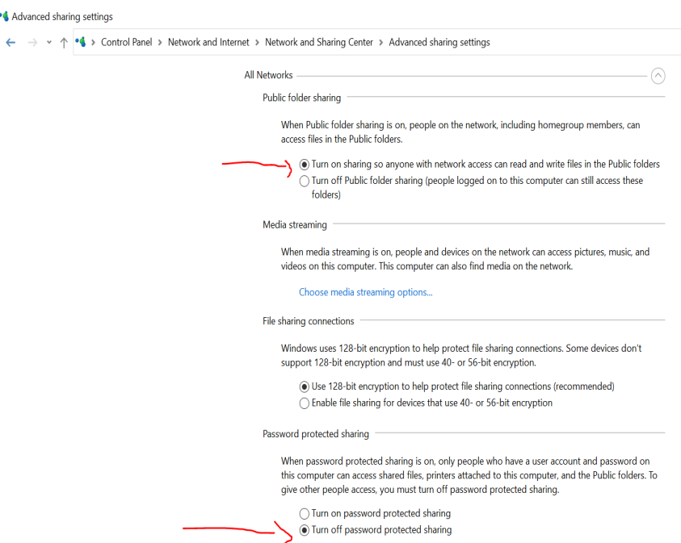

***Step 3: Setup Static IP***

**1- Goto Control Panel->Network and Internet->Network and Sharing Center.**

**2- Then On the next window, you will see the active connections which should be**

**Ethernet, since both PCs are connected with a physical LAN cable. Click on the**

**Ethernet link. A new dialog box will open, here click on the Properties button.**

**3- In the next pop-up, select “Internet Protocol Version 4 (TCP/IPv4)”. Now, click on**

**Properties. This will open another dialogue box.**

**4- Here, you need to configure the two PCs with different IP settings. On computer 1,**

**select the option “Use the following IP address.” and, put the following values: IP**

**Address: 192.168.10.10 Subnet mask: 225.225.225.0 Default gateway: empty**

**Of course, it’s not necessary that you use these IP addresses. You can use any Class A or B IP**

**address. In case you are not sure what this all means, better stick with this example. On**

**the second computer, do similar steps, but flip the IP address and Default gateway**

**values: IP address: 192.168.10.5 Subnet mask: 225.225.225.0 Default gateway: empty**

**PC1:**

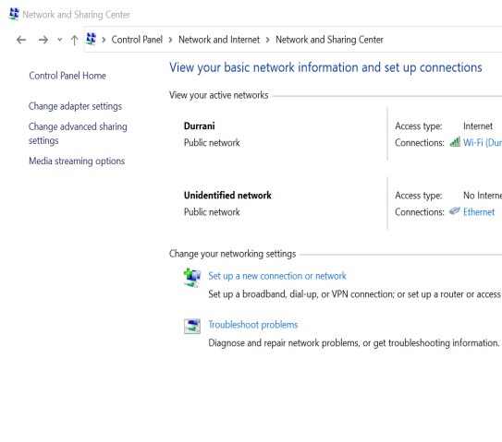

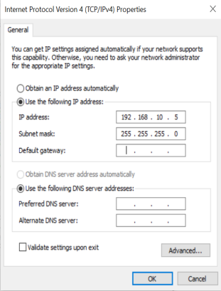

PC2:

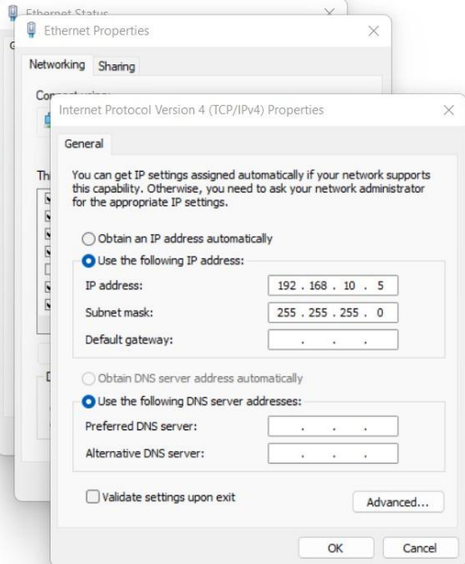

***Step 4: Check Networks on PC’s***

**Next, open your Window’s File Explorer and click on Network tab at the left side of the**

**window. You see two PC’s on your computer.**

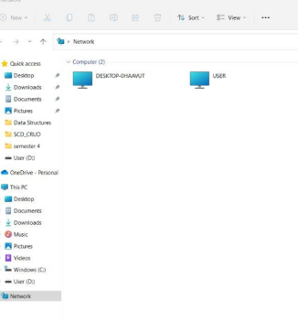

***Step 5: Share a folder***

**1- Next, select the folder you want to share and right-click on it. From the context menu,**

**navigate to “Give access to” and select the option “Specific People.”**

**2- In the File Sharing window, choose Everyone from the drop-down menu. Click on the**

**Add a button next to it and finally hit the Share button.**

**3- Once you have shared it, the next window will show you the network location of the**

**folder.**

**4- That’s it. Just go back to the other PC from where you want to access the file, open**

**the Networks panel and click on the other computer’s name.**

**5- Here, you will see the folder you just shared. From there, just open the folder and**

**transfer the files and folders as you normally do. i.e, by copy and paste. Similarly, you**

**can repeat the same steps from the other computer.**

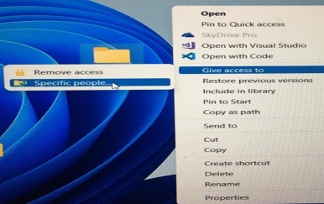

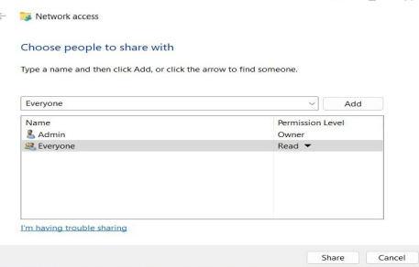

***PC1:***

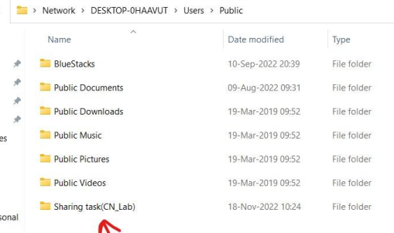

***PC2:***

